**Visa and Passport Management**

**System**

**By:**

ANBUSELVAN. S

ANTOMELVIN. J

# ABSTRACT

Human Resource is a Very important Department in any Organization. Our Project gives in depth solution to one of its important requirements as Visa management Processing. Our project is used to process their visa and store all the details regarding the passport holder. Our project will handle important type of visas like tourist, student visa etc. It will generate all possible reports, which are need by Consulate. It is a Server Project, Admin can be able to create many no of users for applying the visa to travel and can check who are all having the passport, they can apply for the visa.

# TABLE OF CONTENTS

ABSTRACT ii

CHAPTER 1 : INTRODUCTION 1

* 1. INTRODUCTION 1
  2. PROJECT DEFENITION 1
  3. STATEMENT OF PROBLEM 1
  4. PROJECT OBJECTIVES 2
  5. SIGNIFICANCE OF THE STUDY 2
  6. PROJECT SCOPE 3

CHAPTER 2 : LITERATURE REVIEW 4

CHAPTER 3 : SYSTEM ANALYSIS AND METHODOLOGY 6

3.1 METHODOLOGY 7

3.2 DESIGN APPROACH………………………………………………………………………7

3.3.OBJECT ORIENTED DESIGN 9

3.4 ITERATIVE AND INCREMENTAL METHODOLOGY………………………................9

3.5 DATA COLLECTION/GATHERING 10

3.6 ANALYSIS OF THE EXISTING SYSTEM 10

3.7 ANALYSIS OF THE NEW SYSTEM 11

3.7.1 INPUT ANALYSIS 11

3.7.2 OUTPUT ANALYSIS 12

3.8 PROBLEMS OF THE EXISTING SYSTEM 12

3.9 JUSTIFICATION FOR THE NEW SYSTEM 12

CHAPTER 4 : SYSTEM DESHGN AND IMPLEMENTATION 14

* 1. SYSTEM SPECIFICATION 14
     1. GENERAL SYSTEM FUNTION 15

4.1.2 MAIN MENU SPECIFICATION 16

* 1. SYSTEM DESIGN 16

4.3 DATABASE DESIGN 16

4.4 SYSTEM REQUIREMENT 19

4.5 SYSTEM TESTING 19

CHAPTER 5 : SUMMARY,CONCLUSION AND RECOMMENDATION 21

* 1. SUMMARY 21
  2. PROBLEM ENCOUNTERED 21
  3. CONCLUSION 22
  4. RECOMMENDATION FOR FURTHER STUDIES 22

5.5 CONTRIBUTION TO KNOWLEDGE 22

REFERENCES 23

APPENDIX A – SOURCE CODE 24

APPENDIX B – SAMPLE INTERFACES 38

# CHAPTER 1 : INTRODUCTION

## **INTRODUCTION**

Visa and Passport management system is actually a web based application the front end of the application will be your embassy website and the back end will be the visa processing system. The best part of this application is that it can be accessed from any were for example home, office, car, airplane, mobile etc. there is no possibility for of the system to be crashed because the application is stored in a secured web hosting server.

**Domain Name**

Domain name is nothing but the web site address example: www.ovps.com

**Web Hosting**

Web Hosting is the space where your application will be stored.

## **PROJECT DEFINITION**

A Visa is a document issued by a country giving a certain individual permission to enter the country for a giving period of time and for a certain purposes.“Visa Processing System” is an automated system. It describes the process of applying for visa.

There are so many visa types like tourist visa, student visa etc. Getting a Visa, Visa issuance is a very objective decision, and is not subjective. Every visa official has a list of requirements applicant looks for in a visa application. If they are met, then applicant issues the visa. If not, applicant doesn’t. It is how these requirements are met that makes a visa decision seem subjective.

## **STATEMENT OF PROBLEM**

The process of running any organization lies on a good decision making and practice by those in the organization. Hence, decision which also includes task scheduling; and management are paramount factors to any entity’s success or failure. The problems associated with manual visa application (decision making and task (interview) scheduling) are notably thus:

1. High costs which include cost from transportation to communication and so on
2. Absences of confidentiality
3. Stress on the side of both the applicant and interviewer
4. Unnecessary delay in terms on correction and scrutinizing of documents
5. Unnecessary extortion from miscreants around the embassies
6. Though not prominent in all the embassies, bribery and corruption especially those which country’s currency is nothing compared to the country accommodating the embassies
7. Lack of competency among unskilled human resources that claim professionals and so on. This incompetency might be as a result of emotional inference notably, transferred aggression

## **PROJECT OBJECTIVES**

The aim of the research is to develop a computerized visa processing information system. The objectives are as follows:-

1. To build a module for the creation of a new user of the system.
2. To create a module that will check the applicant has passport to apply visa.
3. To create a module that would process visa for applicants.
4. To create a module that could generate cancellation of visa if not needed and can reapply for the visa.

1.5 SIGNIFICANCE OF THE STUDY

The significance of the new system is not narrowed to only the embassies but also to the applicants. This is in terms of cost, time and business identity. This system is not a liability in any sense because there is no extra cost and the payment to unskilled persons in charge of visa application collection and collation will be downsized or stopped.

## **1.6 PROJECT SCOPE**

The scope of this research is centered on the materials and researches that are review in chapter two and literatures on visa application process. More so, the objectives are considered as a scope too.

**CHAPTER 2**

**LITERATURE SURVEY**

Computerized visa processing information system is an information system that tells about the processing of a thing (in this case it is visa). Instead of a visa applicant travelling to the embassy or consulate concerned, he or she just need to fill all the necessary web forms online and upload all the supporting documents. Like the manual system, the class of visa which is determined by the purpose of travel is also taken into cognizance by this automated system. This system is characterized by its decision making ability as well as its management and scheduling abilities. It is an information system basically and also decision making, management and scheduling system.

Information and information systems that support information technology are essential business assets, their availability, integrity and confidentiality are essential to maintain competitive edge, cash flow, profitability and legal compliance and respected company image. Odigie (1996) in Apanapudor, J.S. et al (2006), opined that information is the corner stone of any business establishment; In addition, he said that the channels or information systems through which this information is received are very important. Hence it is essential for any establishment to ensure that sound and effective Information systems are in place. Mandell (1986) in Apanapudor, J.S. et al, said that information system provides stand and reports and most recently, they provide information, that support decision making.

As said earlier, information systems are system that organizes, collects, collates and communicates as well as store information. The information stored are for management used and for decision making. Information system can also be self-decisive. That is, it can be programmed to automatically decide and take action on its own. In this case, the self-decision taken by this system is to decide the date of interview by visa’s applicant. In deciding, different rules are considered like the time of entry or visit by the visa applicant.

‘Information can also be seen in some context as a work system which is a system in which humans or machines perform processes and activities using resources to produce specific products or services for customers. An information system is a work system whose activities are devoted to capturing, transmitting, storing, retrieving, manipulating and displaying information. Information systems inter relate with data system on one hand and activity system on the other hand. As a form of communication system, data are represented and processed as a form of social memory’.

Next we collect, sort and classify data regarding the problem. Data collected must be representative of the problem, upon this, the data are analyzed to unveil the possible relationships—positive, negative no relationship between the data using appropriate data analysis tools. Thereafter we identify possible constraints and alterative courses of action are noted and used to compare other alternatives. This may require additional data. At this point the objective of the organization plays some crucial roles.

We observe that the decision making process is a closed loop so the process may continue until an optimal choice is made from the alternative courses of action.

Each of these levels needs information for making decision for actualizing the goals and objective of the organization and so managers at all levels must be provided with decision oriented information. Mandell (1986) in Apanapudor, J.S. et al, opined that since information needs at the three levels differs, data has to be structured differently at each level.

At the low level, management is interested in the daily activities of the organization. Hence the data / information needed are largely internal and the scope well defined and narrow.

In the middle level interest is on goal attainment so as to meet the objectives of the organization. Hence tactical decisions are prevalent here. The information requirements for decisions at this level include periodic reports and occasionally “what if reports, financial management and employee problem decisions are common”.

At the top level, managers are more objective minded, future oriented and often interested in resources allocation since the pattern of decisions is on — off type. Data/information required are on-time reports, trend analysis reports and also data that are organized to provide inquiry capacity across functional lines and to handle routine information reporting.

# CHAPTER 3

# SYSTEM ANALYSIS AND METHODOLOGY

3.1 METHODOLOGY

The specified procedures for the research work involving data collection and analyzing in respect to define or solve the research problem(s) is called research methodology or methodology. According to Wikipedia.com, “Methodology is the systematic or theoretical analysis of the methods applied to a field of study (research works mainly). Methodology comprises of the theoretical analysis of the body of methods and the principles associated with a branch of knowledge”.

***MODEL + TECHNIQUE(S) = METHODOLOGY***

This research system is concerned with computerization of visa processing and generation of information. Each visa applicant is automatically given an application identity which is a random code concatenated with the first five letters of the applicant’s current nationality. This application code help to track activities in regards to that application. The passport number wasn’t used because a passport can have more than one visa from the same country notably, visiting visa, student visa and tourist visa. The processing is totally computerized and information is retrieve or gotten when the applicant logs in into his/her application page. Visa interview is immediately schedule ones the applicant has filled all the requisites information to enable the algorithm/program (code) for the interview scheduling.

3.2 DESIGN APPROACH

Top down and bottom up designs significantly makes up the type of design approach in computer science. These design approaches are employed to mitigate a problem (problem solving). The top-down (stepwise/decomposition design) is the breaking down of a system to gain insight of the subsystem composition in a reverse engineering pattern (like roofing before setting of blocks), that is a big picture is broken down into smaller segments. Bottom-up entails the piecing together of systems to give to more complex system, hence making the complex system a sub system of the emergent systems. A clearer picture is the decking a before laying of bocks for the top down and the laying of blocks before decking for the bottom up.

Top-down design approach has been adopted for this research, this is due to the numerous benefits it has notably, easy debugging and modularization. Hence, the major higher-level system requirements and functions were identified and then broken down into successive steps until function-specific modules were designed. As a level-oriented design approach which directs designers to start with a top-level description of a system with step by step refinement thereby decomposing into lower-level and smaller modules, top-down reduces the scope and size of each module, and focuses more on specific issues.

3.3 OBJECT ORIENTED DESIGN

|  |  |
| --- | --- |
| |  | | --- | | “An object is a collection of variables, data structures, and procedures stored as an entity and forming a basic building block of object-oriented programming”, Microsoft® Encarta® 2009. © 1993-2008 Microsoft Corporation. | |

Objects are also used in the design level of a system. According to google.com, “Object orientation is the act of using a methodology which enables a system to be modeled as asset of objects which can be controlled and manipulated in a modularize manner”.

OOD, as an approach to software design, it is the process of planning a system of interacting objects to solve a software problem. An object contains encapsulated data and procedures grouped together to present an entity. Hence, in the design of this system, the styles (CSS – Cascade Styling Sheet) were on places on each master or content page but the styles have its own item named VISA_StyleSheet.css.

OOD is basically an approach that models the problem in terms of its objects and the operations performed on them by decomposing the system into modules and each of the decomposed modules in the system denotes an object or class of objects from the problem space.

Modularity, abstraction and encapsulation (which is information-hiding) are three important concept in software design and they are promoted in object oriented design.

3.4 ITERATIVE AND INCREMENTAL METHODOLOGY

The Dynamic System Development Method (DSDM) as a development methodology is an iterative and incremental approach that embraces principles of agile development of project management, including continuous user/customer involvement. DSDM was first released in 1994 though in 2007 it was rebranded DSDM Atern. DSDM fixes cost, quality and time at the onset and uses the MoSCoW prioritization of scope. MoSCoW stands for Must, Should, Could and Would; the two os are just to ease pronunciation.

Agile development principle is an iterative and incremental method of manning the design and build activities of system development in a highly flexible and iterative manner. MoSCoW is a prioritization technique used in development and management to reach a common understanding with the stakeholders on the importance of placed on the delivery of each requirement.

Design & Build Iteration

Functional Model Iteration

Implementation

Study-Feasibility & Business

Fig 3.1: The DSDM

3.5 DATA COLLECTION/GATHERING

Data in this research were collected using the following methods:

The methods used in data collection in this research are:

* OBSERVATION – Observation was made on the Indian online visa application system and the knowledge was used in designing and creation of this research system.
* PERSONAL INTERVIEW – I was privileged to interact with some travellers on the processes they took to getting their visa and their responses wasn’t friendly as they totally detest the manual method and all yearns for a computerized system. From this interview process, I got the basic prerequisites for scheduling an interview.
* BROWSING METHOD – Most of the data here apart from the aforementioned methods were gotten from the internet. Pages were visited for increased knowledge and proper literature review.
* BRAINSTORMING – Few of my colleagues and I did brain work especially in the logical aspect of scheduling for a visa interview.

3.6 ANALYSIS OF THE EXISTING SYSTEM

Visa application and processing is still in the manual level at most embassies in the world. In Nigerian embassies, even the process of renewing and having your Nigerian international passport is manual in the sense that it is only in their offices that it can be done and whatever the applicant filled outside the office is not considered for prompt processing.

In the manual system, visa applicant travels to the embassy or consulate and make the necessary application before at a later date the applicant will contacted for interview. This process is hectic, stressful, cumbersome and prone to risk. It also has the other bottleneck of any manual systems. The applicant can’t get information about his/her application until he/she travel to the particular embassy of application. The world is going global hence the need for a computerized visa application system to expedite actions and minimize risk and other holdups.

3.7 ANALYSIS OF THE NEW SYSTEM

Visa processing information system is concerned with the acceptances of visa application from an applicant, keeps the information in strict confidentiality and with the given data/information by the applicant schedule or deny the applicant a visa interview.

This system automatically and instantly gives the applicant an application ID, which is used to track information on the application. With the applicant’s email address and the application ID, the user logins into the system whereby he/she can get the information supplied and update any outdate/erroneously supplied data/information.

The interview is fixed automatically by the system using the following criteria’s: expiry date of the passport, expected date of journey, period of stay. If the expiry date of the passport is already reached, then out rightly the visa applicant will be denied of interview. The expected of journey is considered to know the time the interview is to be fixed to avoid delay. The period of stay is considered to know the duration of visa to be given so that the passport will not expiry during the applicant’s stay in the country.

After the interview is scheduled, all the applicant needs is to report at the interview point with all the supporting documents in original and photocopies for sighting.

3.7.1 Input Analysis

This system gets input from the very moment an applicant for visa starts application. From the new till the last form, data supplied by the applicant makes up the input of the system.

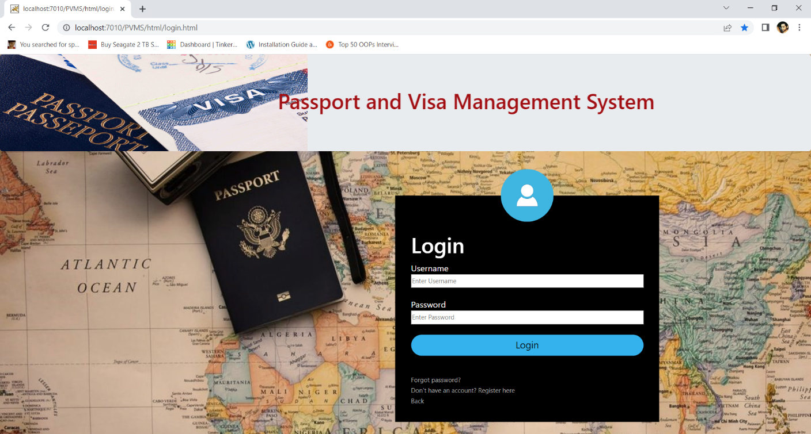

Fig 3.2: login page

3.7.2 Output Analysis

Output proceeds after every successful processing of data inputted. The output of this system is that the visa has been applied. For this to take place, the applicant must log into the system and visit the aforementioned links.

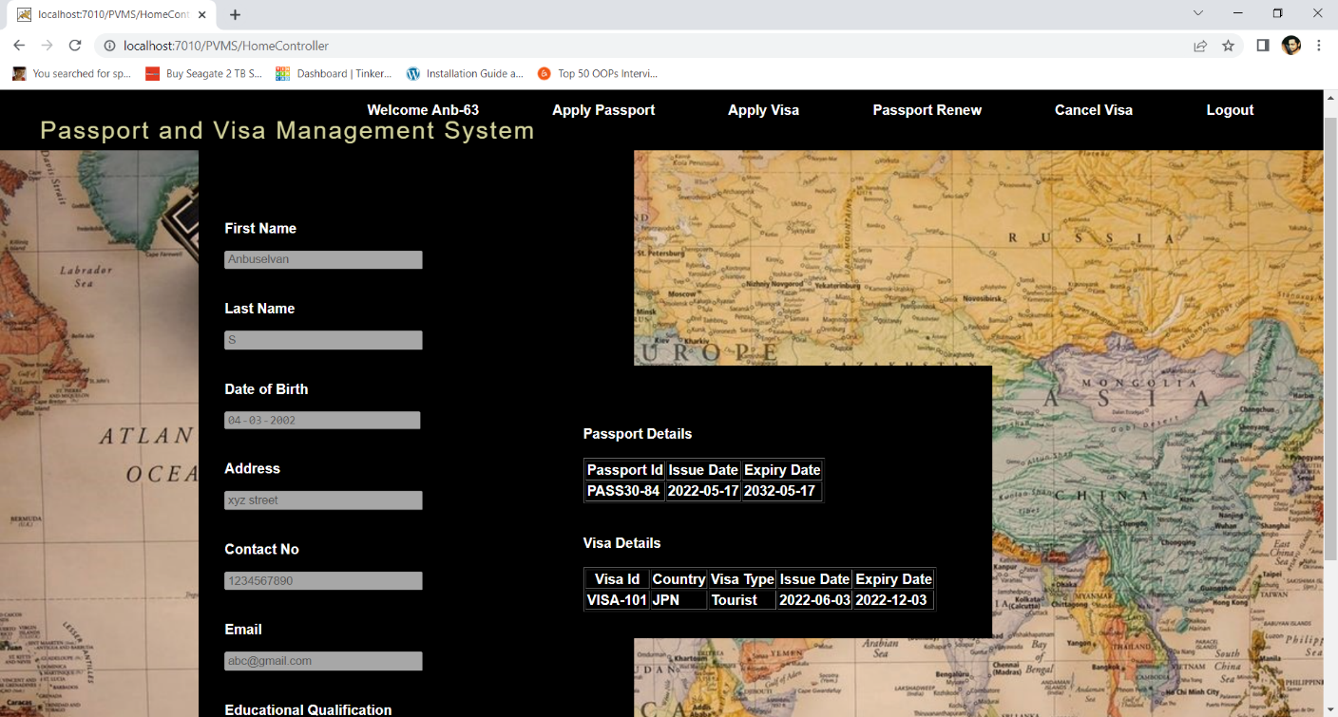

Fig 3.3: Output Form

3.8 PROBLEMS OF THE EXISTING SYSTEM

Lots of problems are associated with the present system. These problems are:

* Delay and stress of visa applicant
* Loss of documents and ill confidential system of handling information
* Compromise of visa officers in charge of application
* Too much expenses and risk
* Inability for applicant to access their application at anytime

3.9 JUSTIFICATION FOR THE NEW SYSTEM

As a result of the data collection methods employed in this research, this system has been built eradicate/ minimize the shortcoming of the present (manual) system. Modules like track progress and interview helps the applicant to speedily and in microseconds get information about his/her applicant instead of travelling to the embassy/consulate. Hence the introduction of this new system will birthed a lot of positive changes.

CHAPTER FOUR

SYSTEM DESIGN AND IMPLEMENTATION

Automated system must be implemented to ascertain the level of success or otherwise .An automated system that is not implemented or is not successful implemented cannot replace the previous system because of its ill performance. Stella (2006) said, “Even after the development phase is over, the system project isn’t complete. The new system must be implemented or installed”.

4.1 SYSTEM SPECIFICATION

This system comprises of both master pages and content pages which at the source have html tags and asp.net codes. Also among the system java script and cascade styling sheets also made the system. Although not all of the html codes can be seen here but a description is given here hence the following made up the system:

* 1. Hyperlinks: This helps in the linkage of pages in the system.
  2. MenuList: This is implemented to form like the system’s tabs.
  3. Label: This carries the texts that are not in a button or menu strip.
  4. Buttons: This enables actions to be carried out once it is clicked.
  5. Image and image button: This is for pictures to be displayed.
  6. Gridview: This is use like the phonebook of the system, showing the contact and their details.
  7. Textboxes
  8. Dropdownlist
  9. Checklistbox
  10. Hyperlinks and link buttons
  11. Divs
  12. Tables

4.1.1 GENERAL SYSTEM FUNCTION

The functions of the system are listed below:

* To enter the login details for the user to apply visa
* After login process the user goes to the visa applying website
* If the user has not having passport then he cant apply visa so first the user need to have the passport
* If the user has already the passport means then he can apply for the visa
* The user can take any type of visa to any country

4.1.2 MAIN MENU SPECIFICATION

The home page of this system displays the hyperlinks to the various content pages. The initial page (Home page) have seven (7) hyperlink in the Menu list. This is eluding the login hyperlink and log out hyperlink. Amongst this tabs three tabs can be accessed with the status of a guest user, that is without logging in. The Home Page, About Pages and the Contact Page are not dynamic pages, they are static.

4.2 SYSTEM DESIGN

Dynamic System Design Methodology (DSDM) was applied in the design of this system. In describing the system, Unified Modeling Language (UML) which was formulated by Booch, Rumbaugh and Jacobson in 1997 and the use Case diagram shows the system design diagrammatically. In specifying, visualizing and constructing the artifacts of software system UML was used and it comprises of diagrams such as sequence diagram, state diagram, collaboration diagram and some others of which use case diagram among and used here.

A Use Case diagram shows typical interactions between a user (actor) and the computer system. As defined by Stella (2006) in their book principle of system analysis and design, use case are included in Unified Modeling Language and it is a narrative document that describes the sequence of event of an actor using a system to complete a process.

We apply a use case diagram which is graphical representation of the systems functionality by the different users. The use case diagram consists of actors, use cases and arrows (for evens of flow).

Visa applicant, the general public and the administrator makes up the actors, (users) in the use case diagram. The use cases are those function that the actors (users) which ranges from mainly applying for a visa, tracking their application, view their interview date as scheduled by the system. The arrows in the diagram below are the direction of flow (event) specifying what module the user can use.

The use case diagram of this automated system is given below.

4.3 DATABASE DESIGN

Database is seen as a warehouse of data and a repository for data and information in an organized way to prevent redundancy and to preserve data integrity amongst others. The database was named PVMS.

Sql developer was used as the database (backend) for this system. The database comprises of tables which are: **Table for login and Table for Visa applying** among others. A table in the database comprises of the field name, data type and allow null when viewed in the design view.

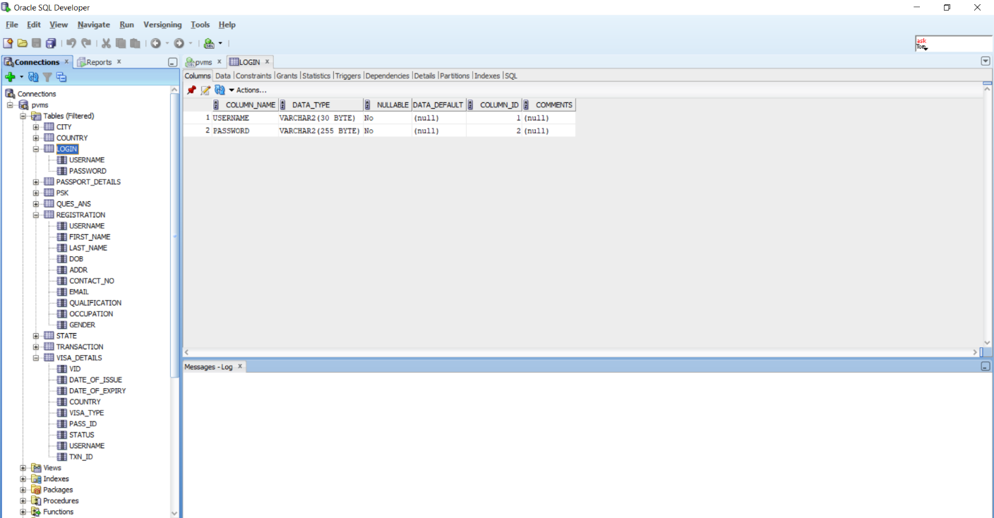

Fig 4.2 Table for Login

Fig 4.3 Table for Visa applying

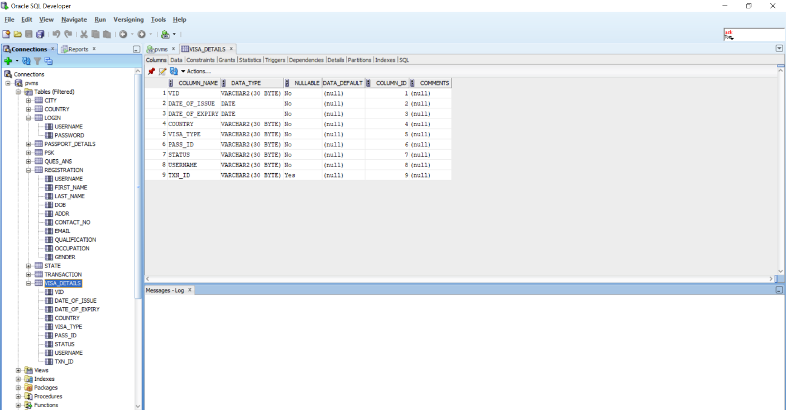

**Use Case Diagram** - Shows the description of Visa processing System

The use case diagram depicts the system and the functions that can be performed by actors are indicated with the direction of flow.

## **Use Case Diagram**

**User**

**Can apply**

**passport**

**Can renewal**

**The passport**

Also the user can do

**Logout**

**The id**

4.4 SYSTEM REQUIREMENT

For the implementation of this system, all that is needed are as follows:

The following hardware components are needed

* 1. Computer System – a desktop or laptop(mini laptop and tablets can also access the system online if it is launched)

The computer system should have the minimum requirement to access the internet. Hence, when speed is not the focus it should have:

* 1. Pentium 3 Processor
  2. 512 kb RAM
  3. 10 GB Hard disk
  4. A web browser (any of Mozilla, Chrome, Crazy Browser and others)

4.5 SYSTEM TESTING

For testing sake, a local web server (IIS) application, microsoft.net framework was installed & properly configured. The operating system used is windows 8.0. Dummy data were used to test the system.

“Before a system is put into operation, its components programs must be tested to make sure. They work both individually and as a unit. Testing whether unit testing (individual testing) or individual testing, removes bugs from individual programs and system application. The testing of this system is done with life data and test data.

An automated system may have a hundred programs and a comprehensive database, all must be tested together to ensure harmony of operation. The purpose of system testing is to validate all software, input/output, databases and procedures and so on as the case may be”, said Hampo, J.A.C. (2011).

This involves running a series of tests on the new system, so as to check for errors and to verify that all components of the system are run simultaneously and then observation and comparisons are made and documented. This is done to ensure that the new system holds true to the advantages it should have over the existing system without posing any complications of its own.

System testing should be done before the new system and any new system / system component is fully implemented, so as to correct any occurrence of low usability in portions of the system.

CHAPTER FIVE

SUMMARY, CONCLUSION AND RECOMMENDATION

5.1 SUMMARY

Information and data is vital and should not be a thing played with or keep unprotected. This project has put in measures to protect the data and information. Also, the processing time to schedule for an interview has been automated to be immediately the needed information are supplied.

The stress free and risk limited nature of this system promotes the health and safety of the applicants. The worth of this over the existing system is as follows:

* 1. Efficiency
  2. Accuracy
  3. Reliability
  4. Prompt and instantaneous response
  5. Speed
  6. Users friendliness with simple GUI
  7. Easy Accessibility

5.2 PROBLEMS ENCOUNTERED

The problem encountered was on the accessibility of an existing visa information system to serve as a template to design this system but during my interaction with some travellers, they furnished me with the needed information.

5.3 CONCLUSION

Automated systems are more successful when compared with the manual or traditional systems. The increased speed, confidentiality and ease of use are some of the successes of automated system over traditional or manual system.

Visa information processing system has so many advantages over the traditional system. The risk of travelling for visa application; and re-travelling for information on the application and interview date has been eradicated by this system. All the applicant needed to track his or her application is just the Application ID, moreover the number of application for visa is not limited to an applicant.

Finally, the issues of paper work have been reduced; hence no more report of misplaced or lost application in visa issuing embassies or consulates.

5.4 RECOMMENDATION FOR FURTHER STUDIES

Further research is advice on this research to facilitate on the system’s function and design. The inclusion of more modules and feature like the use of biometric should be incorporated in upcoming research.

5.5 CONTRIBUTION TO KNOWLEDGE

CAPTCHA meaning Completely Automated Public Turing test to tell Computers and Human Apart; and implemented in this research has contributed to the knowledge challenge-response test used in human computing to determine whether or not the user is human.

# 

APPENDIX A – SOURCE CODE

**Home.jsp:**

<%@ page language="java" contentType="text/html; charset=ISO-8859-1" pageEncoding="ISO-8859-1"%>

<%@ page import = "java.io.*,java.util.*,com.pvms.bean.User,com.pvms.bean.Passport,com.pvms.bean.Visa,java.time.LocalDate" %>

<!DOCTYPE html PUBLIC "-//W3C//DTD HTML 4.01 Transitional//EN" "http://www.w3.org/TR/html4/loose.dtd">

<html>

<head>

<%

response.setHeader("Cache-Control","no-cache"); //Forces caches to obtain a new copy of the page from the origin server

response.setHeader("Cache-Control","no-store"); //Directs caches not to store the page under any circumstance

response.setDateHeader("Expires", 0); //Causes the proxy cache to see the page as "stale"

response.setHeader("Pragma","no-cache");

String uname=(String)session.getAttribute("uname");

if(uname==null)

{

response.sendRedirect("/PVMS/html/login.html");

return;

}

User u=(User)session.getAttribute("user");

Passport pass=u.getP();

ArrayList<Visa> visas=u.getVisas();

String []occups={"Private Employee","Government Employee","Retired","Student","Self Employed"};

LocalDate ld=LocalDate.now();

String maxDate=ld.getYear()+"-"+ld.getMonthValue()+"-";

if(ld.getDayOfMonth()<10)

maxDate+="0"+ld.getDayOfMonth();

else

maxDate+=ld.getDayOfMonth();

%>

<meta http-equiv="Content-Type" content="text/html; charset=ISO-8859-1">

<meta charset="UTF-8">

<meta name="viewport" content="width=device-width, initial-scale=1.0">

<meta http-equiv="X-UA-Compatible" content="ie=edge">

<link rel="stylesheet" type="text/css" href="<%= request.getContextPath()%>/css/home.css">

<script src="https://ajax.googleapis.com/ajax/libs/jquery/3.2.1/jquery.min.js"></script>

<script src="<%= request.getContextPath()%>/js/home.js"></script>

</head>

<body>

<div class="wrapper">

<nav>

<div class="menu-icon">

<i class="fa fa-bars fa-2x"></i>

</div>

<div class="logo">

Passport and Visa Management System

</div>

<div class="menu">

<div id="container">

<ul>

<li>Welcome <%= uname %></li>

<li><a href="<%= request.getContextPath()%>/PassportController?opt=opt1">Apply Passport</a></li>

<li><a href="<%= request.getContextPath()%>/VisaController?opt=opt1">Apply Visa</a></li>

<li><a href="<%= request.getContextPath()%>/PassportController?opt=opt6">Passport Renew</a></li>

<li><a href="<%= request.getContextPath()%>/VisaController?opt=opt4">Cancel Visa</a></li>

<li><a href="<%= request.getContextPath()%>/jsp/logout.jsp">Logout</a></li>

</ul>

</div>

</div>

</nav>

<div id="bg">

</div>

<form id="display" method="post" action="<%= request.getContextPath()%>/HomeController" class="dashbox1">

<input type="hidden" name="opt" value="submission">

<p>First Name</p>

<input type="text" name="fname" value="<%= u.getFirstName() %>" class="inputDisabled" pattern="[a-zA-Z]{1,25}" title="Please enter alphabets only" required disabled>

<p>Last Name</p>

<input type="text" name="lname" value="<%= u.getLastName() %>" class="inputDisabled" pattern="[a-zA-Z]{1,15}" title="Please enter alphabets only" required disabled>

<p>Date of Birth</p>

<input type="date" name="dob" value="<%= u.getDob() %>" class="inputDisabled" max="<%= maxDate %>" required disabled>

<p>Address</p>

<input type="text" name="addr" value="<%= u.getAddress() %>" class="inputDisabled" required disabled>

<p>Contact No</p>

<input type="tel" name="tel" value="<%= u.getContactNo() %>" class="inputDisabled" pattern="[0-9]{10}" title="Please enter a 10 digit number" required disabled>

<p>Email</p>

<input type="email" name="email" value="<%=u.getEmail() %>" class="inputDisabled" required disabled>

<p>Educational Qualification</p>

<select name="edu" class="inputDisabled" required disabled>

<option value="<%=u.getEdu() %>"><%= u.getEdu() %></option>

<%

if(u.getEdu().equals("Bachelor's Degree"))

out.println("<option value=\"Master's Degree\">Master's Degree</option>");

else

out.println("<option value=\"Bachelor's Degree\">Bachelor's Degree</option>");

%>

</select>

<br><br>

<p>Occupation</p>

<select name="occup" class="inputDisabled" required disabled>

<option value="<%=u.getOccup() %>"><%= u.getOccup() %></option>

<%

for(String s:occups)

{

if(!s.equals(u.getOccup()))

out.println("<option value=\""+s+"\">"+s+"</option>");

}

%>

</select>

<br><br>

<input type="submit" id="button1" value="Edit">

</form>

</div>

<div class="dashbox2">

<b>Passport Details</b><br><br>

<%

if(pass==null)

out.println("No Passport<br><br>");

else {

%>

<table border="1px solid white">

<tr>

<th>Passport Id</th><th>Issue Date</th><th>Expiry Date</th>

</tr>

<tr>

<td><%= pass.getId() %></td><td><%= pass.getIssuedate() %></td><td><%= pass.getExpirydate() %></td>

</tr>

</table><br><br>

<%

}

%>

<b>Visa Details</b><br><br>

<%

if(visas.isEmpty())

out.println("No Visas<br>");

else{

%>

<table border="1px solid white">

<tr>

<th>Visa Id</th><th>Country</th><th>Visa Type</th><th>Issue Date</th><th>Expiry Date</th>

</tr>

<%

for(Visa v:visas)

out.println("<tr><td>"+v.getVid()+"</td><td>"+v.getCountry().getId()+"</td><td>"+v.getVisaType()+"</td><td>"+v.getDateOfIssue()+"</td><td>"+v.getDateOfExpiry()+"</td></tr>");

}

%>

</table>

</div>

</body>

</html>

**Applyvisa.jsp:**

<html>

<head>

<%@ page import="java.util.*" %>

<%@ page import="com.pvms.bean.Country" %>

<%

response.setHeader("Cache-Control","no-cache"); //Forces caches to obtain a new copy of the page from the origin server

response.setHeader("Cache-Control","no-store"); //Directs caches not to store the page under any circumstance

response.setDateHeader("Expires", 0); //Causes the proxy cache to see the page as "stale"

response.setHeader("Pragma","no-cache");

String uname=(String)session.getAttribute("uname");

if(uname==null)

{

response.sendRedirect("/PVMS/html/login.html");

return;

}

String pass_Id=(String)request.getAttribute("pass_Id");

if(pass_Id==null)

{

response.sendRedirect("/PVMS/jsp/home.jsp");

return;

}

String occupation=(String)request.getAttribute("occupation");

ArrayList<Country> countries=(ArrayList<Country>)request.getAttribute("countries");

session.setAttribute("countries",countries);

%>

<link rel="stylesheet" type="text/css" href="<%= request.getContextPath()%>/css/style.css">

<link rel="stylesheet" type="text/css" href="<%= request.getContextPath()%>/css/bootstrap.min.css">

<div class="jumbotron text-center">

<marquee><h1>Passport and Visa Management System</h1></marquee>

</div>

</head>

<body>

<div class="loginbox">

<img src="<%= request.getContextPath()%>/images/visa3.jpg" class="avatar">

<h1>Apply Visa</h1>

<form method="post" action="<%= request.getContextPath()%>/VisaController">

<input type="hidden" name="opt" value="opt2">

<p>User Id: <%= uname %></p>

<p>Passport Number: <%= pass_Id%> </p>

<p>Country</p>

<select name="country">

<%

for(Country c:countries)

{

%>

<option value=<%= c.getId() %>><%= c.getName() %></option>

<%

}

%>

</select>

<p>Visa Type</p>

<select name="visa_type">

<% if(occupation.equals("Student"))

out.println("<option value=\"Student\">Student</option>");

else

out.println("<option value=\"Work\">Work</option>");

%>

<option value="Tourist">Tourist</option>

</select>

<br><br>

<input type="submit" name="" value="Submit">

<a href="<%= request.getContextPath()%>/jsp/home.jsp">Back</a>

</form>

</div>

</body>

</head>

</html>

**Cancelvisa.jsp:**

<html>

<head>

<%@page import="java.util.List,com.pvms.bean.Visa" %>

<%

response.setHeader("Cache-Control","no-cache"); //Forces caches to obtain a new copy of the page from the origin server

response.setHeader("Cache-Control","no-store"); //Directs caches not to store the page under any circumstance

response.setDateHeader("Expires", 0); //Causes the proxy cache to see the page as "stale"

response.setHeader("Pragma","no-cache");

String uname=(String)session.getAttribute("uname");

if(uname==null)

{

response.sendRedirect("/PVMS/html/login.html");

return;

}

List<Visa> visas=(List<Visa>)request.getAttribute("visas");

String passId=(String)request.getAttribute("passid");

if(visas.size()==0||passId==null)

response.sendRedirect("/PVMS/jsp/home.jsp");

%>

<link rel="stylesheet" type="text/css" href="<%= request.getContextPath()%>/css/style.css">

<link rel="stylesheet" href="<%= request.getContextPath()%>/css/bootstrap.min.css">

<div class="jumbotron text-center">

<marquee><h1>Passport and Visa Management System</h1></marquee><br>

</div>

<body>

<div class="loginbox">

<img src="<%= request.getContextPath()%>/images/visacancel.jpg" class="avatar">

<h1>Visa Cancellation</h1>

<form method="post" action="<%= request.getContextPath()%>/VisaController">

<input type="hidden" name="opt" value="opt5">

<p>User ID: <%= uname %></p><br>

<p>Passport Number: <%= passId %></p><br>

<p>Select a Visa :</p>

<select name="vid">

<%

for(Visa visa:visas)

{

%>

<option value="<%= visa.getVid() %>"><% out.println(visa.getVid()+" "+visa.getCountry().getId()+" "+visa.getVisaType());%>

</option>

<%

}

%>

</select>

<br><br>

<input type="submit" name="" value="Submit">

<a href="<%= request.getContextPath()%>/jsp/home.jsp">Back</a>

</form>

</div>

</body>

</head>

</html>

APPENDIX B – SAMPLE INTERFACES

Visa home Page

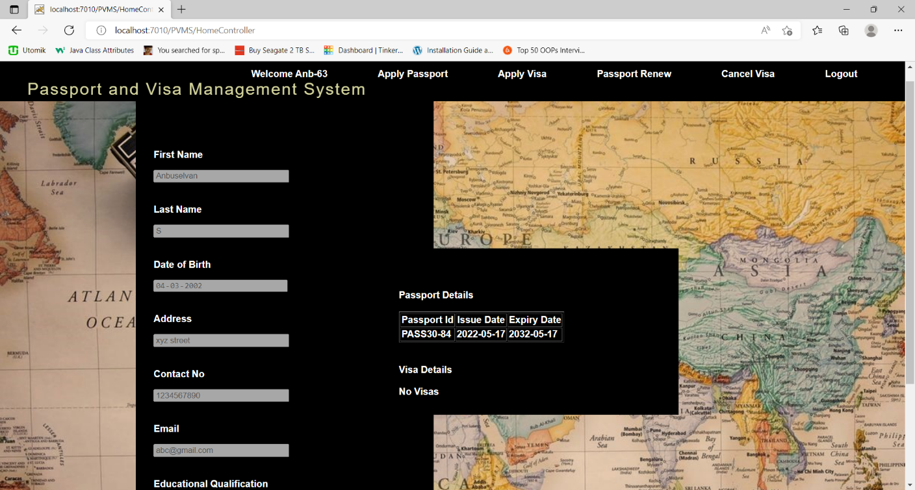

Applying the visa page

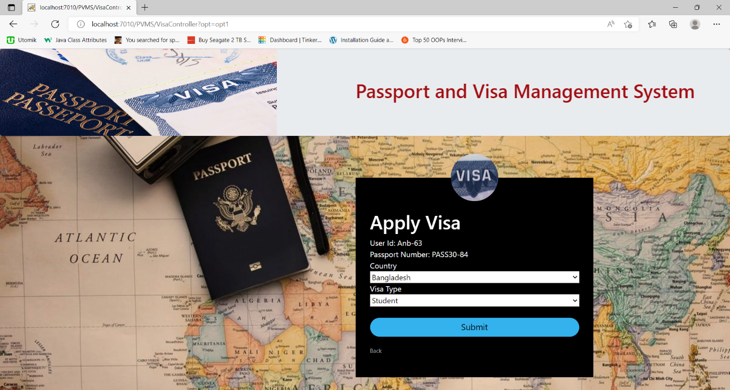

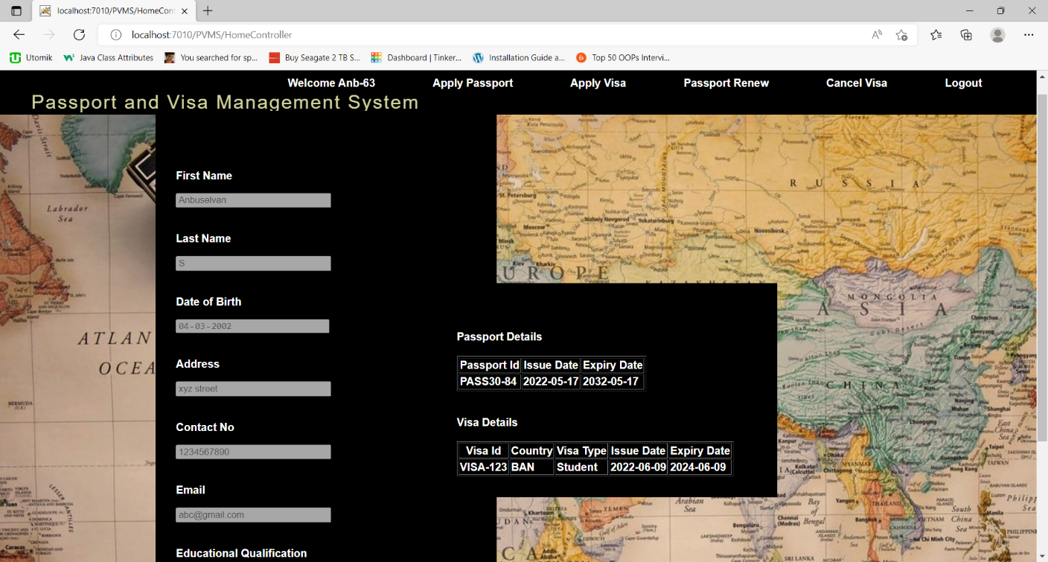

Cancelling the visa page

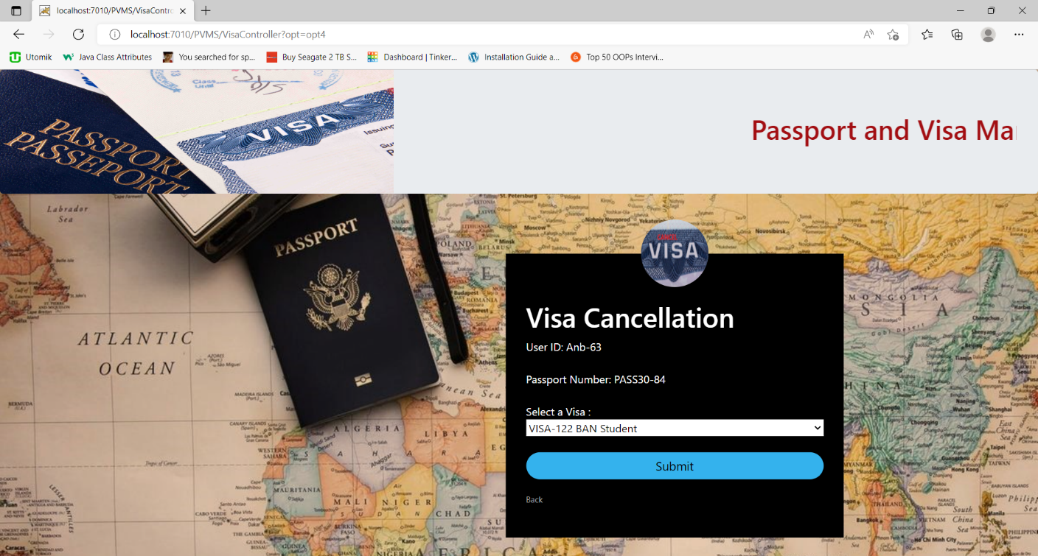

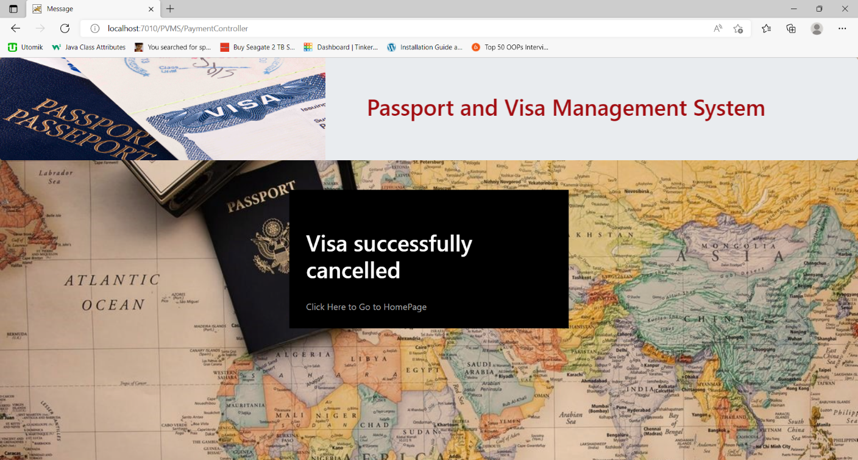

REFERENCES

Apanapudor, J.S., Njoseh, I.N., Ogini, N.O., and Omede, G.C. (2006). Introduction to computer science and data processing [A Practical Approach]. Reprinted. Krisbec Publications, Agbor – Nigeria.

Byron, S.G. (2001). Theory and Problems of Programming with visual basic Schaum’s Outline. McGraw – Hill USA.

David, C. Van Essen and Charles, H. Aderson. (2005). Information Processing Strategies and Pathways in the Primate Visual System. Department of Anatomy & Neurobiology Washington University School of Medicine St. Louis, MO, USA.

Escalle, C. (February, 1999) Enterprise resource planning. Harvard Business Review.

Hampo, J.A. (2011). Design and Implementation of Students Verification System for Delta State University Nigeria (DELSU E-VERIFY). An unpublished B.Sc Thesis, Delta State University, Abraka-Delta State.

Hopper, M. (May, 1990). Rattl1ing SABRE-New ways to compete on information. Harvard Business Review.

Martinsons, M.G. and Davison R.M. (2007). Strategic decision making and support systems: Comparing American, Japanese and Chinese management. Decision Support Systems. 43. 284–300.

Sikiru, O.A. (2009). Implementation of an Online Job recruitment system. An unpublished M.IT Thesis, University of Lagos, Nigeria.

Stella, C.C. and Franca, A.E (2006). Principles of System Analysis and Design. Rootprint and publisher, Benin city – Nigeria.

Sasan, Rahmatian. (2003). Transaction Processing Systems. Encyclopedia of Information Systems. Volume 4. 479 – 488. California State University, Fresno – USA

Uzoka. (1998). Human Resources Management an unpublished M. Tech Thesis, federal University of Technology, Akure, Ondo State.

Waheed, Uz Zaman Bajwa. (2009). New Information Processing Theory and Methods For Exploiting Sparsity In Wireless Systems. PhD Thesis, University of Wisconsin – Madison, USA.